Tree Data Structure.
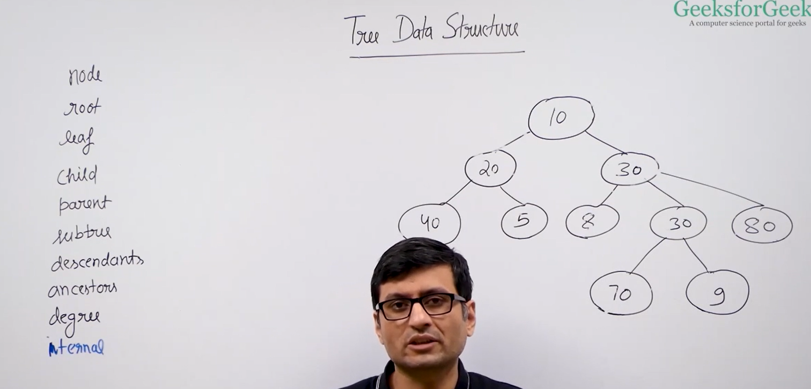
Tree → A family of information connected like branches.
Root → The very first and top-most member of the tree.
Leaf → The last member with no children.
Parent → A member that has children below it.
Child → A member directly below a parent.
Subtree → A small tree inside a big tree.
Descendant → All members below someone (children, grandchildren...).
Ancestor → All members above someone (parents, grandparents...).
Degree → Number of direct children a member has.
Internal → Any member that has at least one child (not a leaf).


